IN723 Lab 3 MPLS VPN – Central Services (VIRL)

In this lab we will build upon lab2 (MPLS VPN). In this lab SITE-D is now operating as a central services site (YUTANI-CENTRAL) providing internent access for both WEYLAND and OMNICORP. Sites A, B & C will have access to the central services site yet WEYLAND and OMNICORP will still be isolated from each other.
Note – This lab cannot be completed in packet tracer
Note - Start at step 8 if continuing from Lab 2. You will also have completed parts of subsequent steps, be sure to check your config. The new config for this lab is on R1, R3 and SITE-D.
Central services considerations – May lead to overlapping address space (not in this lab) = resolve with NAT or enforcing public address space.

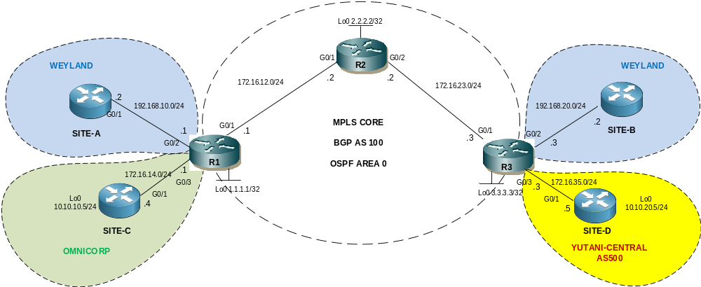

- The switches are used to allow multiple students to simulatenously connect to the routers using telnet.
IP Addressing
Interface | IP Address | Notes | VRF Forwarding
R1 G0/2 | 192.168.10.1/24 | R1 - SITE-A | WEYLAND
R1 G0/1 | 172.16.12.1/24 | R1 – R2
R1 G0/3 | 172.16.14.1/24 | R1 – SITE-C | OMNICORP
R1 Lo0 | 1.1.1.1/32 | Loopback
R2 G0/1 | 172.16.12.2/24 | R2 – R1
R2 G0/2 | 172.16.23.2/24 | R2 – R3
R2 Lo0 | 2.2.2.2/32 | Loopback
R3 G0/2 | 192.168.20.1/24 | R3 – SITE-B | WEYLAND
R3 G0/1 | 172.16.23.3/24 | R2 – R3
R3 G0/3 | 172.16.35.3/24 | R3 – SITE-D | YUTANI-CENTRAL
R3 Lo0 | 3.3.3.3/24 | Loopback
SITE-A G0/1 | 192.168.10.2/24 | SITE-A – R1
SITE-B G0/1 | 192.168.20.2/24 | SITE-B – R3
SITE-C Lo0 | 10.10.10.4/24 | SITE-C LAN
SITE-C G0/1 | 172.16.14.4/24 | SITE-C – R1
SITE-D Lo0 | 10.10.20.5/24 | SITE-D LAN
SITE-D G0/1 | 172.16.35.5/24 | SITE-D – R3

Step 1 - Physical
- Physically cable the lab as per the above diagram using IOSv nodes.

Step 2 – PE to P IP addressing
- Configure IP addressing on R1 connection to R2, & R2 to R3 as per the diagram / table. Do not configure the LAN interfaces (facing SITES A – D) yet.

Step 3 – CE addressing
- Configure IP addressing on SITE-A, SITE-B, SITE-C, SITE-D as per the diagram / table.

Step 4 – OSPF
- Configure single area OSPF between R1, R2 & R3. Use the loopback addresses as router-ids
- Advertise loopbacks vis OSPF (needed for MPLS LDP peering)

Step 5 – MPLS LDP
- Confirm CEF is enabled (show ip cef) on each P & PE router.
- Configure the MPLS label protocol as ldp (mpls ldp label protocol ldp) on R1, R2 & R3
- Configure the MPLS ldp router-id as the loopback on each router (mpls ldp router-id loopback 0)
- Enable MPLS forwarding on the WAN interfaces of R1, R2 & R3 (mpls ip)
- Verify MPLS neighbors (show mpls ldp neighbor)

Step 6 – MP-BGP PE to PE
- Configure MP-BGP (iBGP) between R1 and R3. Note that with MPLS VPNs, next-hop self is not required as the PE will re orginate routes learned from the CE, though having turned on will not harm and is often seen in practice. Note P nodes do not participate in BGP, their role is simply to switch labelled packets.

R1 config
router bgp 100
bgp router-id 1.1.1.1
no bgp default ipv4-unicast
bgp log-neighbor-changes
neighbor 3.3.3.3 remote-as 100
neighbor 3.3.3.3 description PE R3
neighbor 3.3.3.3 update-source Loopback0
!
address-family vpnv4
neighbor 3.3.3.3 activate
neighbor 3.3.3.3 send-community extended

R3 Config
router bgp 100
bgp router-id 3.3.3.3
bgp log-neighbor-changes
no bgp default ipv4-unicast
neighbor 1.1.1.1 remote-as 100
neighbor 1.1.1.1 description PE R1
neighbor 1.1.1.1 update-source Loopback0
!
address-family vpnv4
neighbor 1.1.1.1 activate
neighbor 1.1.1.1 send-community extended

Step 7 – Confirm MP-BGP
- Verify MP-BGP peering
show ip bgp vpnv4 all summary

Step 8 – Central Services VRF & Customer VRF on R3
- Configure the new central services VRF YUTANI-CENTRAL and the WEYLAND VRF on R3 as per the below.
Note that YUTANI-CENTRAL is importing a route-target (120:120) that is common to both WEYLAND and OMNICORP vrfs (they set their VPN membership with the route-target export command). In addition WEYLAND and OMNICORP (OMNICORP is defined on R1) are both importing 300:300 which YUTANI-CENTRAL VPN routes belong to. WEYLAND’s and OMICORP’s orginal route-targets (100:100 & 200:200) are still in operation and are still isolated from each other. A VPN prefix can be configured with more than one route-target which in turn means it can belong to more than one VPN.

ip vrf YUTANI-CENTRAL
rd 300:300
route-target both 300:300
route-target import 120:120
!
ip vrf WEYLAND
rd 100:100
route-target both 100:100
route-target export 120:120
route-target import 300:300

Note: You can remove the omnicorp vrf from R3 if you wish (from Lab2), it will not affect anything if it remains.
Step 9 – Define customer VRFs R1
- Configure VRFs WEYLAND & OMNICORP on R1 as per the following
ip vrf WEYLAND
rd 100:100
route-target both 100:100
route-target export 120:120
route-target import 300:300
!
ip vrf OMNICORP
rd 200:200
route-target both 200:200
route-target export 120:120
route-target import 300:300

Step 10 – Attach VRFs to interfaces and configure IP addressing
- Configure the LAN interfaces on R1 & R3 in the correct VRF as per the IP addressing table
e.g for R1 – SITEA
interface g0/2
ip vrf forwarding WEYLAND

Note: If you are working from Lab2 then you will need to reconfigure the ip vrf forwarding command for the SITE-D connection (it is now YUTANI-CENTRAL).

- Configure IP addressing for the LAN interfaces on R1 & R3 as per the IP addressing table
Confirm with:
show ip vrf interfaces
Note: If you are working from Lab2 then you will need to reconfigure the IP addressing on R3 for the SITE-D connection.

Step 11 – PE to CE WEYLAND
- Configure R1 to advertise SITEA into the WEYLAND VPN using redistribute connected
router bgp 100
address-family ipv4 vrf WEYLAND
redistribute connected

- Configure R3 to advertise SITEB into the WEYLAND VPN using the BGP network command
router bgp 100
address-family ipv4 vrf WEYLAND
network 192.168.20.0 mask 255.255.255.0

Step 12 – PE to CE OMNICORP
- Configure R1 and SITE-C to advertise SITE-C’s loopback into the OMNICORP VPN using BGP.
R1
router bgp 100
address-family ipv4 vrf OMNICORP
neighbor 172.16.14.4 remote-as 400
neighbor 172.16.14.4 activate

SITE-C
router bgp 400
neighbor 172.16.14.1 remote-as 100
network 10.10.10.0 mask 255.255.255.0

Step 13 – PE to CE YUTANI-CENTRAL
- Configure R3 and SITE-D to eBGP peer using the YUTANI-CENTRAL VPN
R3

router bgp 100
address-family ipv4 vrf YUTANI-CENTRAL
neighbor 172.16.35.5 remote-as 500
neighbor 172.16.35.5 activate

SITE-D

router bgp 500
neighbor 172.16.35.3 remote-as 100

Step 14 – Advertise a defaulte route from SITE-D (YUTANI-CENTRAL)
- Create a static default null route and redistribute it into BGP on SITE-D. Note that this will also require the bgp command default-information originate. Alternatively default-information originate can be used with a neighbor statement, this then does not require the default route to already exist (e.g the default null route).

Step 15 – Verify VPN routes
- View the BGP VPN tables on R1 and R3 (note R2 does not participate in BGP and has no knowledge of the VPN routes).
show ip bgp vpnv4 all
Note the next hop is the remote PE (1.1.1.1 or 3.3.3.3)

- Confirm that the default route is present in all VRFs and that SITE-A, SITE-B & SITE-C are present in the YUTANI-CENTRAL VRF

Step 16 – Verify VPN labels
- Use the following command to view the VPN label assigned to the prefix. Note this will be the bottom label of the 2 label stack as the packet is forwarded over the MPLS core. The remote PE router will use this label to determine which VRF to perform a route lookup for the packet’s destination IP address.
show ip bgp vpnv4 all labels

Step 17 – Verfiy MPLS LDP label mappings
- View the LIB (label information base) on R2 to see next-hop labels learned from downstream neighbors (& locally generated) mapped to IP prefixes
show mpls ldp bindings
- View the LFIB (label forwarding information base) on R2 to see the local label to next-hop label mappings along with the outgoing interface
show mpls forwarding table
- Note that these label mappings relate to the IGP label, which is the top label of the stack. This is the same label we observed in lab1

Step 18 – Confirm connectivity
- Confirm SITE-A loopback can ping SITE-B loopback
- Confirm SITE-A loopback can ping 10.10.20.5 (SITE-D)
- Confirm SITE-C loopback can ping 10.10.20.5 (SITE-D)

Step 19 – View MPLS label operation in action
- Send a continuous ping from PCA to PCB (or PCC to PCD)
- Use the debug command to view MPLS forwarding in real time on R2
debug mpls packet
- Note that the debug shows both labels in the stack. The bottom label determines the VPN and is only used by the PE routers (R1 & R3). The top label is used to traverse the MPLS core and is swapped at each hop, before popped (removed) at the penultimate hop.
Note - if debugging is already enabled on the router & is not showing up (default for telnet access) then use the command term mon to view the debug output. To turn off debugging use undebug all

